1.

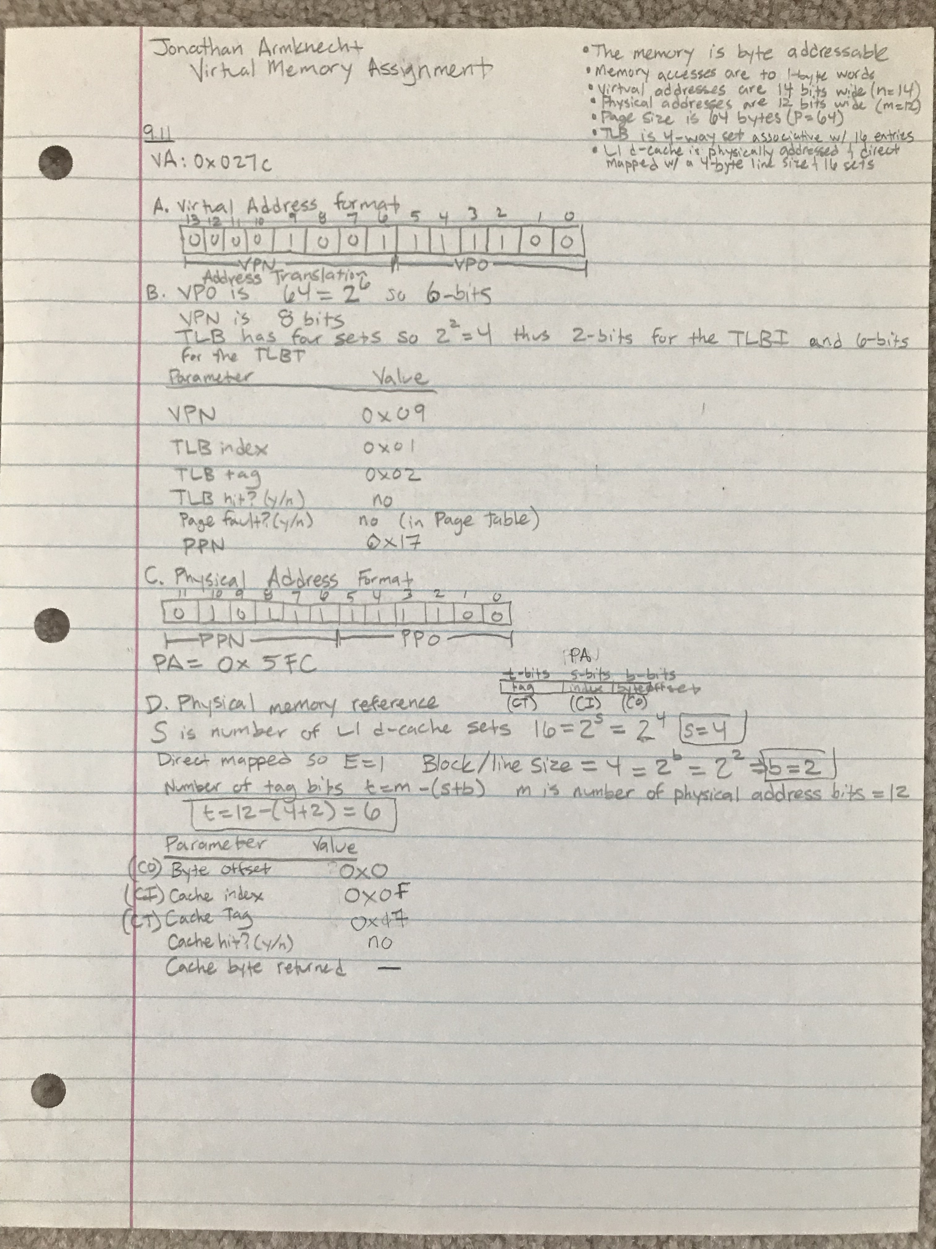

2.

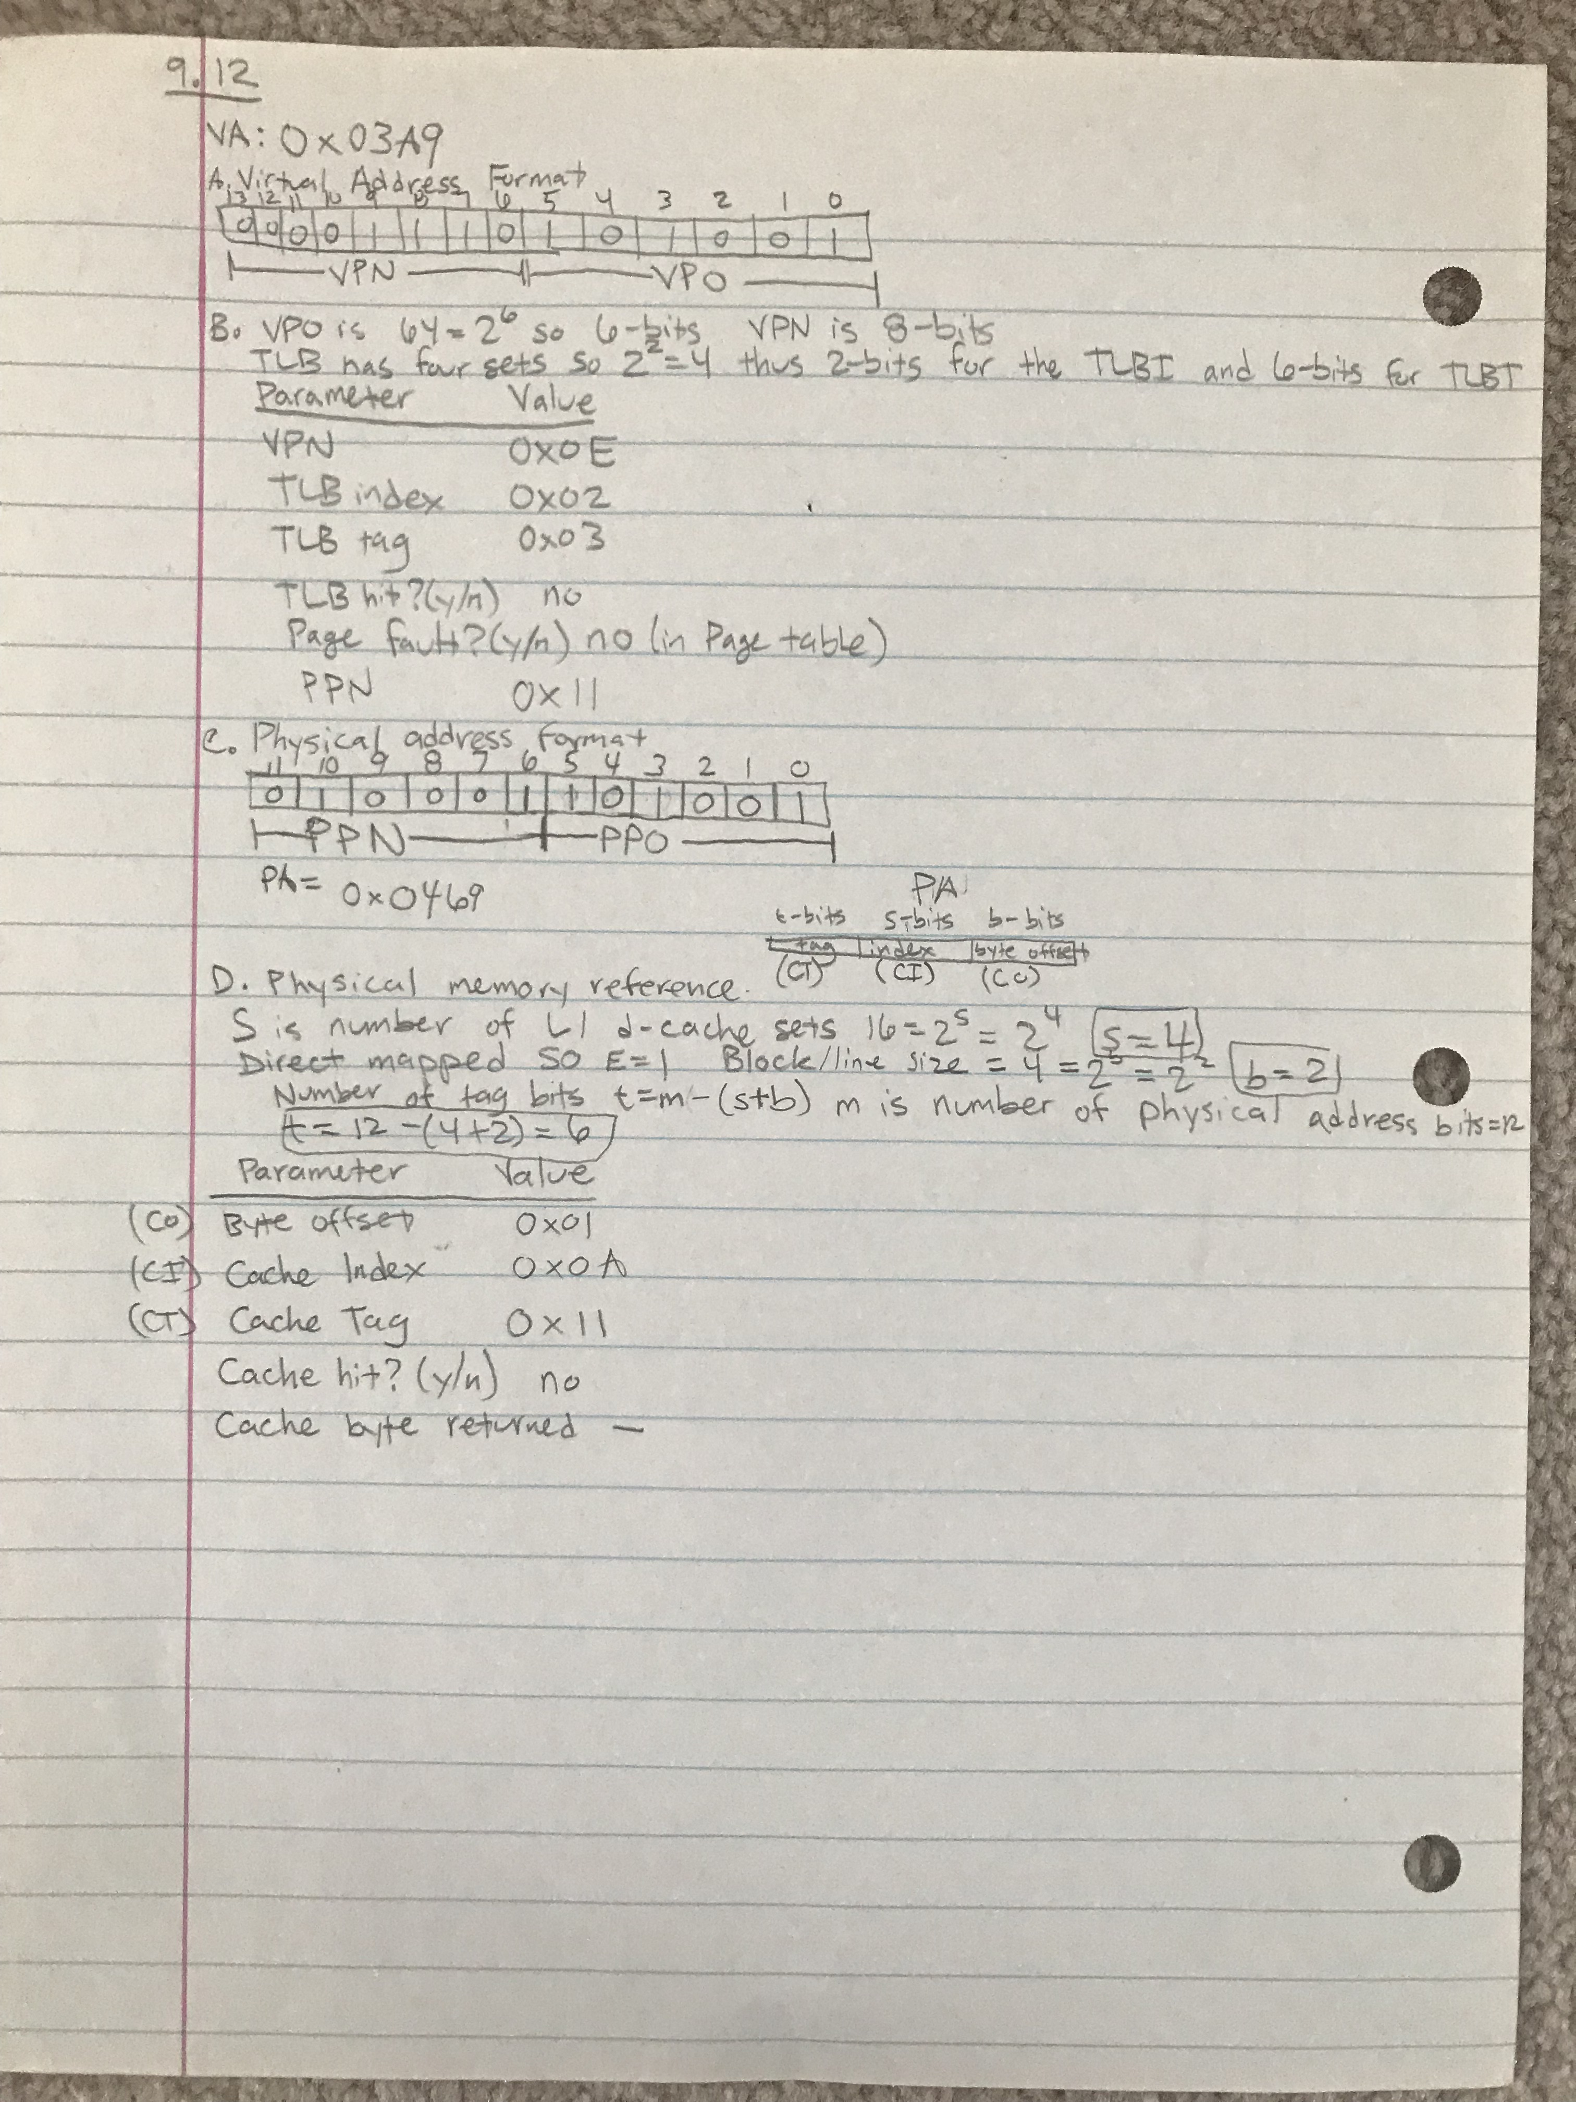

3.

#include <fcntl.h>

#include <stdio.h>

#include <stdlib.h>

#include <unistd.h>

#include <sys/mman.h>

#include <sys/stat.h>

#include <sys/types.h>

int main (int argc, char* argv[]) {

int fd; //Holds file descriptor

struct stat sb; //Holds stats of the file

char *buf; //Holds what mmap returns pointer to the mapped region

size_t size; //Holds the offset size of the file from the stats struct

fd = open("hello.txt", O_RDWR, NULL); //Opens hello.txt for reading and writing

if (fd < 0) { //if fd is < 0 open failed

fprintf(stderr, "Could not open file\n");

exit(1);

}

if (fstat(fd, &sb) < 0) { //Calls fstat which returns info about a file and stores that info in sb

//if fstat failed -1 will be returned

fprintf(stderr, "Could not fstat file\n");

exit(1);

}

size = sb.st_size; //Gets the total size in bytes of the file descriptor fd

/*

* Tells kernel to create a new area of virtual memory where

* pages can be written and read and it is a shared object between processes containing

* size bytes. Buf will hold the address of the new area created

*/

buf = mmap(NULL, size, PROT_READ|PROT_WRITE, MAP_SHARED, fd, 0);

if (buf < 0) { //Mmap failed!

fprintf(stderr, "Could not mmap\n");

exit(1);

}

printf("%s", buf); //Reads the virtual memory area and prints it to the console

buf[0] = 'J'; //Takes buf and writes J as the first letter in the buffer

printf("%s", buf); //Reads the virtual memory area and prints it to the console

if (munmap(buf, size) < 0) { //unmaps the virtual memory area that is pointed to by buf and consists of size bytes

//if munmap fails it returns -1

fprintf(stderr, "Could not unmap\n");

exit (1);

}

if (fd != -1) { //a file needs to be closed

if (close(fd) < 0) { //closes the text file

//closing the file failed

fprintf(stderr, "Could not close file\n");

exit(1);

}

}

return 0;

}



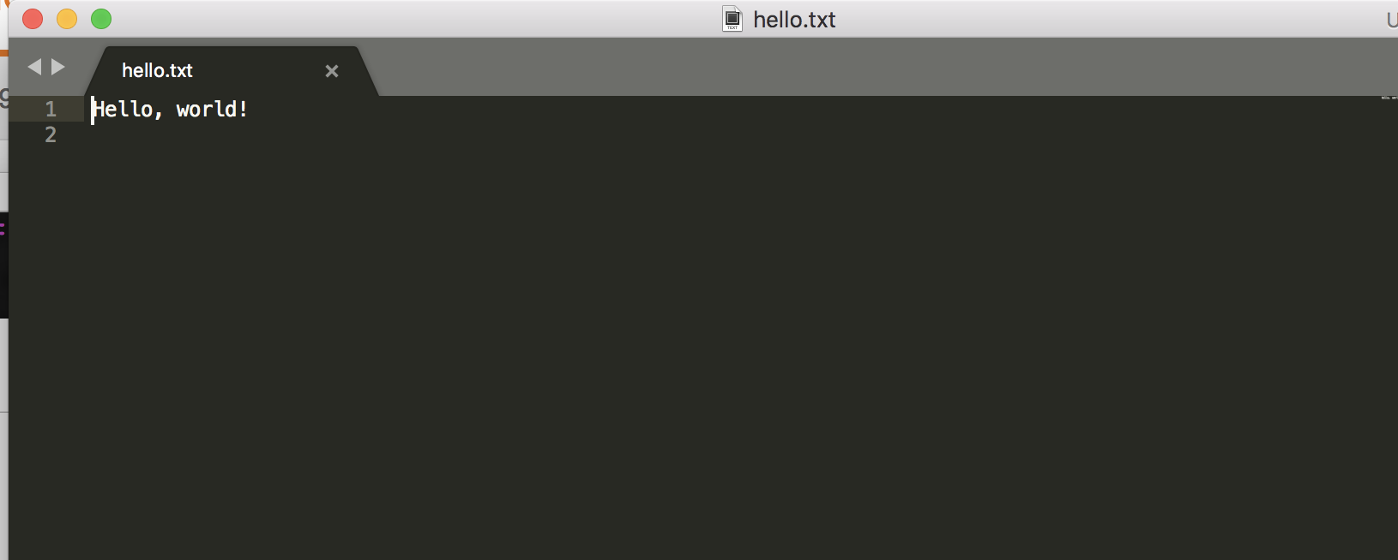

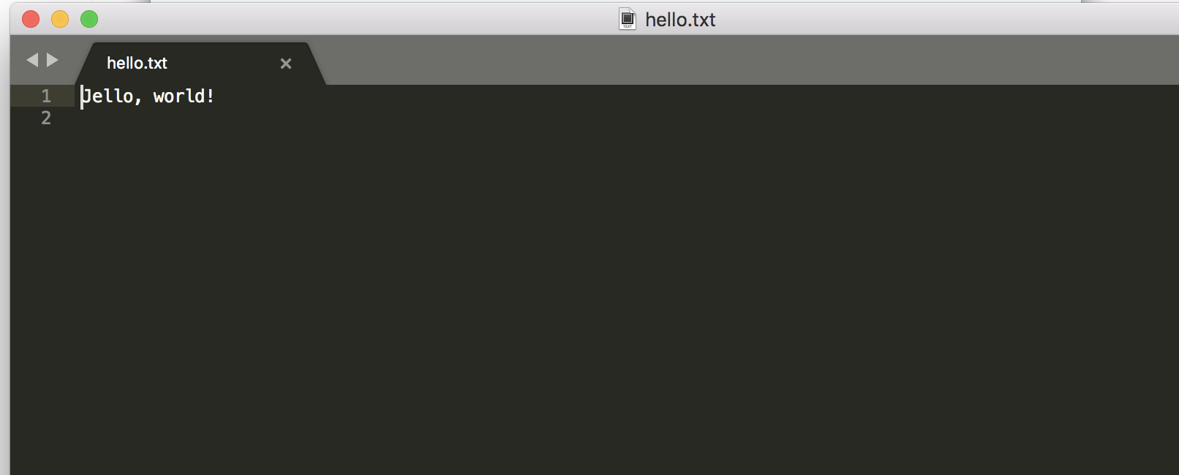

4.

